
RAMAIAH
Institute of Technology
USN | 1 | M | S

(Autonomous Institute, Affiliated to VTU)
(Approved by AICTE, New Delhi & Govt. of Karnataka) Accredited by NBA & NAAC with ‘A’ Grade

EXAMINATIONS SEPTEMBER /OCTOBER 2020
SUPPLEMENTARY SEMESTER / GRADE IMPROVEMENT/ RE –REGISTERED CANDIDATES
Program | : | B.E.: Electrical and Electronics Engineering | Semester | : | V
Course Name | : | Linear Integrated Circuits | Max. Marks | : | 100
Course Code | : | EE54 | Duration | : | 3 Hrs

Instructions to the Candidates:
- Answer one full question from each unit.

 |  | UNIT- I
1. | a) | Draw and explain the block diagram of an op-amp. Also, explain the function of each block. | CO1 | (06)
 | b) | Bring out the difference between a voltage follower and an emitter follower. | CO2 | (04)
 | c) | A direct coupled inverting amplifier with a +15V supply is to produce maximum possible output voltage and is to have a voltage gain of 40dB. The amplitude of the input voltage is to be 50mV AC. Using 741 Op-Amp, design a suitable circuit. Ensure that the circuit is suitably compensated for I_{B}R_{B} drop. Draw the circuit diagram with the component values mentioned on it. Also calculate the input and the output impedance for the circuit designed (From 741 data sheet: typical open loop gain=200000; typical open loop input impedance=2MΩ; typical open loop output impedance=75Ω). | CO2 | (10)
2. | a) | - Two signals that each range from 0.1V to 1V is to be summed and amplified by a factor of 5. Using an LF353 op-amp, design a suitable inverting summing circuit. Sketch the circuit with component values mentioned on the circuit. Use +15V supply.  - If the circuit designed in section (i) has to work as an averaging circuit with an amplification factor of 5, what should be the value of the resistor connecting inverting terminal to ground? (keep all other parameters and component values same). | CO2 | (10)
 | b) | Define the following parameters with respect to IC 741 op-amp:  (i) Input voltage range (ii) CMRR (iii) SVRR (iv) output offset voltage | CO1 | (04)
 | c) | - Calculate the maximum output voltage of an op-amp shown below in fig. 2c(i), if the op-amp has Vin=5 mV, Iib =500nA, R1=1kΩ and Rom= 909Ω.Note: Iib- Input bias current  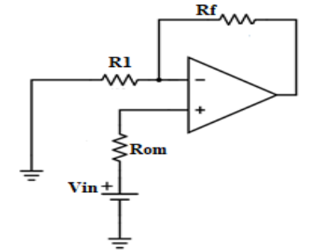  Fig. 2c(i)  - For the circuit given below in fig. 2c(ii), if the CMRR of the operational amplifier is 60 dB, then the magnitude of the output voltage is  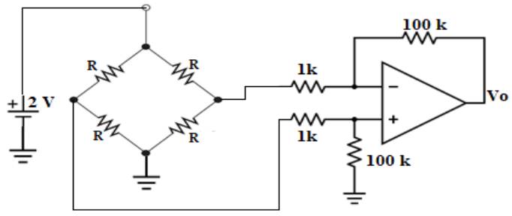  Fig. 2c(ii) | CO1 | (06)
 |  | UNIT- II
3. | a) | Using a 741 op-amp, design a high Z_{in} non inverting amplifier to operate with a +36V power supply. The load resistance is 12kΩ, the lower cut off frequency is to be 150Hz and the voltage gain is to be 7. Draw the circuit with component values mentioned on it. | CO2 | (10)
 | b) | The non-saturating precision half wave rectifier has to rectify (pass) only positive half cycle of the input voltage. using bipolar Op-amp, design a suitable circuit which produces a 5V peak output from a sine wave input with a peak value of 0.5V and the frequency of 1MHz. Use supply voltage of +15V. Draw the circuit with component values mentioned on it. | CO2 | (06)
 | c) | Discuss the advantages of a precision rectifier over an ordinary diode rectifier circuit. | CO2 | (04)
4. | a) | A capacitor coupled difference amplifier is to have two input voltage with each range from 200mV to 2V. The lowest signal frequency is 300Hz, the load resistance is 3.3kΩ and the voltage gain is to be 5. Design a suitable circuit using BIFET LF353 op-amp. Draw the circuit with component values mentioned on it. | CO2 | (10)
 | b) | With a neat sketch and waveform throughout the circuit, explain the working of high input impedance precision full wave rectifier. Derive an expression for its output voltage. | CO2 | (10)
 |  | UNIT- III
5. | a) | - Design a narrow band pass filter so that the center frequency f_{c}=500Hz, Q=13 and A_{F}=5  - Redesign the circuit by changing the center frequency to 700Hz and keeping A_{F} and the bandwidth constant.  Draw the circuit with component values mentioned on it. | CO2 | (10)
 | b) | Using bipolar op-amps, design a precision rectifier peak detector circuit to handle a peak input of 1V. The minimum rise time of the input is 30µs, the holding time is to be 300µs and the maximum output error is to be 5%. Calculate the required component values and specify the output current and slew rate of the operational amplifier. Assume diode reverse leakage current as 1µA. Sketch the circuit with component values mentioned on it. | CO2 | (10)
6. | a) | Design the triangular wave generator so that frequency of oscillation f₀=10kHz and V_{0(P-P)}=10V. Use 741 op-Amp with a supply voltage of +15V. Draw the circuit diagram with component values mentioned on the circuit. Also sketch the expected waveform. | CO2 | (08)
 | b) | A +1.5V signal is to be sampled by a sample and hold circuit. The holding time is to be 700µs, and the output accuracy is to be approximately 0.3%. LM108 op-amps are to be used, and the available FET has a 25Ω channel resistance and a 300nA gate – source reverse leakage current. Design the circuit and determine the minimum acquisition time. Draw the circuit with component values mentioned on it. (For LM108 data sheet I_{B(max)}=2nA). | CO2 | (08)
 | c) | Design a Wien bridge oscillator for an oscillating frequency of 2kHz. Draw the circuit with component values mentioned on it. | CO2 | (04)
 |  | UNIT- IV
7. | a) | Design a non-inverting Schmitt trigger with V_{UT} = 5V and V_{LT} = 1V. Use 741 op-amp with a supply voltage of +15V. Draw the circuit, with component values mentioned on it. Also, draw the input, output waveforms and hysteresis curve for the circuit designed. | CO2 | (08)
 | b) | i) Calculate the cutoff frequency limited rise time for a voltage follower circuit using a 741 op-amp. Also determine the slew rate limited rise time, if the output amplitude is to be 5V.  ii) Determine the maximum undistorted pulse output amplitude for the 741 voltage follower, if the output rise time is not to exceed 1 µs.  iii) Calculate the minimum output rise time and the maximum pulse amplitude at that rise time, for a 741 amplifier with an upper cutoff frequency of 100kHz.  (for 741 op-amp gain bandwidth product is 800kHz, slew rate is 0.5V/µs). | CO3 | (08)
 | c) | Discuss the necessity of positive feedback for a voltage level detector. | CO2 | (04)
8. | a) | Sketch a circuit, to show Zin mod method of frequency compensation and explain its operation. Also, state the application of the circuit and write equation for the feedback factor. | CO3 | (07)
 | b) | Design an inverting Schmitt trigger with V_{UT} = 5V and V_{LT} = -5V. Use 741 op-amp with a supply voltage of +15V. Draw the circuit with component values mentioned on it. Also, draw the input, output waveforms and hysteresis curve for the circuit designed. | CO2 | (07)
 | c) | With the help of suitable sketch, briefly explain the following compensation methods:  - Phase lag compensation  - Phase lead compensation | CO3 | (06)
 |  | UNIT- V
9 | a) | With a neat sketch explain the working of voltage to current converter with grounded load. Also derive an expression for the load current I_{L}. | CO4 | (06)
 | b) | Briefly explain the typical performance parameters for a voltage regulator. | CO5 | (04)
 | c) | i) With a neat sketch and waveforms, explain the working of 555 timer as a monostable multivibrator  ii) Suggest suitable modifications need to be made to the monostable multivibrator such that it works as a frequency divider circuit.  iii) Monostable mutivibrator is to be used as a divided by 2 network (frequency divider). The frequency of the input trigger signal is 2KHz. If the value of C = 0.01μF, what should be the value of R_{A}? | CO5 | (10)
10 | a) | Design a free running ramp generator using 555 timer for a free running frequency of 4 KHz. Assume V_{cc} = 5V and V_{BE} = 0.7 V. Sketch the circuit with component values mentioned on it. | CO5 | (08)
 | b) | With a neat sketch explain how the current to voltage converter with floating load can be used as a diode match finder, zener diode tester and Light emitting diode tester. | CO4 | (08)
 | c) | With a neat circuit diagram and waveform, explain the working principle of astable multivibrator. | CO5 | (04)

****************

